**Team Inventory**

**October 7, 2022**

**Team Teacher To-Do**

**Project Sponsor:** Chris Aungst

**Faculty Mentor:** Michael Leverington

**Team Members:**

Sam Gerstner (Team Lead)

Alexander Frenette

Noah Nannen

Shlok Sheth

Bronwyn Wedig

**Overview**

The purpose of this team inventory document is to briefly introduce the members of our team. The following pages briefly outline the training, skills, and relevant experience of each team member. We hope that this document will better assist our team in distributing work amongst team members, as well as provide an opportunity for our client to get to know us better.

**Name:** Sam Gerstner (Team Leader)

**Major:** Applied Computer Science

**Hometown:** Phoenix, AZ

**Education:**

* **Pinnacle High School (Phoenix, AZ)**

*High School Diploma*

August 2015 – May 2019

* **Northern Arizona University (Flagstaff, AZ)**

*Bachelor of Science in Applied Computer Science*

August 2019 – May 2023

Relevant Course Work:

- CS386: Software Engineering

- CS312: Web Design II

- CS345: Database Systems

**Work Experience:**

* **Applications Programmer (Flagstaff, AZ)**

Northern Arizona University: *May 2022 – Present*

Manage the automated job scheduling platform for the university and ensure continuity of university operations.

* **Apprentice Software Engineer (Flagstaff, AZ)**

Northern Arizona University: *March 2021 – May 2022*

Assisted with the development and testing of ASP .NET Core, PHP, and other applications to support the operations of the university.

* **Student Tech Sr. (Flagstaff, AZ)**

Northern Arizona University: *August 2020 – March 2021*

Provide technical assistance to NAU students, faculty, and staff via phone, email, and chat.

**Other Interests:**

I have always had a passion for technology, and so when it came time to pursue my degree, I knew what I wanted to major in. I have worked for ITS in some capacity since I started as a freshman at NAU and have gained a lot of valuable work experience during my time with ITS. I am always looking for areas that I can improve in and learn more about.

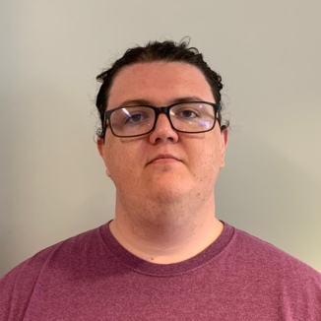 **Name:** Alexander Frenette

**Major:** Computer Science

**Hometown:** Phoenix, AZ

**Education:**

* **University of Arizona (Tucson, AZ)**

*Bachelor of Science in Computer Science*

Relevant Course Work

- CSC 436: Software Engineering

- CSC 337: Web Programming

- CSC 346: Cloud Computing

* **Northern Arizona University (Flagstaff, AZ)**

*Bachelor of Science in Computer Science*

August 2021 – May 2022

**Skills:**

* System Architecture
* Web API Design
* Database Design
* Cloud Management and Deployment

**Other Interests:**

My passion is problem solving and optimization. The opportunity to learn and challenge myself is something I find great pleasure in. Recently I have been exploring embedded software as it applies to drones, automation, and botany. The topics of reforestation, agriculture technology, as well as renewable energy and energy use optimization are areas I have great interest in and will be necessary for the future of our world.

**Name:**  Noah Nannen (User Interface Developer)

**Major:** Applied Computer Science

**Hometown:** Glasford, IL

**Education:**

* **Estrella Foothills High School (Goodyear, AZ)**

*High School Diploma*

August 2015 – May 2019

* **Northern Arizona University (Flagstaff, AZ)**

*Bachelor of Science in Applied Computer Science*

August 2019 – May 2023

Relevant Course Work:

- CS386: Software Engineering

- CS212: Web Design

- CS312: Web Design II

**Work Experience:**

* **IT Developer (Bayfield, CO)**

Home Depot: *March 2020 – August 2020*

Altered UI elements for the online purchasing application, as well as the customer service interface.

**Other Interests:**

I love storytelling and gaming! I run a D&D campaign currently spanning over a year, and I am currently creating a story-based game. I like creating things and enjoy technology (when it decides to work with me).

**Name:** Shlok Sheth (Full Stack Developer)

**Major:** Computer Science

**Hometown:** Pune, India

**Education:**

* **Pima Community College (Tucson, AZ)**

*Associate of Science*

Concentration: *Computer Science*

August 2019 – May 2021

* **Northern Arizona University (Flagstaff, AZ)**

*Bachelor Computer Science*

August 2021 – May 2023

Relevant Course Work:

- CS386: Software Engineering

- CS345: Database Systems

- CS212: Web Design I

- CS421: Algorithms

**Work Experience:**

* **Apprentice Programmer (Flagstaff, AZ)**

Northern Arizona University: *May 2022 – Present*

Maintain and develop websites and applications on the nau.edu domain. Testing new applications and confirming new functionality during development for the NAU IT department.

* **Teaching Assistant (Flagstaff, AZ)**

Northern Arizona University: *January 2022 – Present*

Grading CS136 – Computer Science II and CS249 – Data Structures weekly coding projects and proctoring for exams.

* **Live-Broadcast Technician (Flagstaff, AZ)**

ESPN+ / Northern Arizona University: *November 2021 – April 2022*

Camera operator, in-game graphics and statistics provider for the live streaming content for Big Sky Women and Men basketball tournament of 2021.

**Other Interests:**

I am fascinated by any piece of technology that works towards making our lives easier and more productive. I am curious about new technology and like to be up-to-date with it. I also like playing video games like Call of Duty and PUBG Mobile. I am also fond of algorithms specifically in computer science.

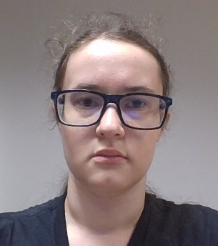 **Name:**  Bronwyn Wedig

**Major:** Computer Science

**Hometown:** Brecksville, OH

**Education:**

* **Bishop Montgomery High School (Torrance, CA)**

*High School Diploma*

* **Northern Arizona University (Flagstaff, AZ)**

*Bachelor of Science in Computer Science*

Relevant Course Work:

- CS386: Software Engineering

- CS212: Web Design

**Other Interests:**

My primary interests are in storytelling and, by extension, the ways that stories can be told in different mediums such as gaming.